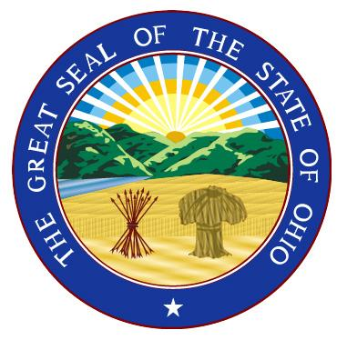
DEPUTY CORONER / FORENSIC PATHOLOGIST

Mahoning County

Employment Availability: Deputy Coroner/Forensic Pathologist

Employer: Mahoning County Coroner’s Office

Application Deadline: Accepting applications until position is filled. Looking to fill the position
as soon as possible.

Responsibilities:

Under the direction of the Coroner, the Deputy Coroner/Forensic Pathologist oversees the office in the absence of the Coroner. This includes overseeing autopsies and external examinations, interpreting results and relaying information to the public and media. Located in Youngstown Ohio, the Mahoning County Coroner’s Office serves a population of approximately 235,000 residents, and the Forensic Pathologist performs approximately 125-150 autopsies per year. The Forensic Pathologist interprets autopsy, histology, and toxicology results rendering an expert opinion regarding the cause and manner of death for all cases. The Forensic Pathologist oversees the operation of the morgue.

Compensation: $140,000/year (negotiable) + Benefits

Qualifications: American Board of Pathology certification preferred. Board eligibility required.

How to apply:

If you are interested in this position and would like to submit your resume/curriculum vitae, please contact:

David M. Kennedy, M.D., Mahoning County Coroner
345 Oak Hill Avenue, Suite 320
Youngstown, Ohio 44502
330-740-2175
DMKKMD@aol.com

