Special Investigator Positions (2) at Connecticut OCME
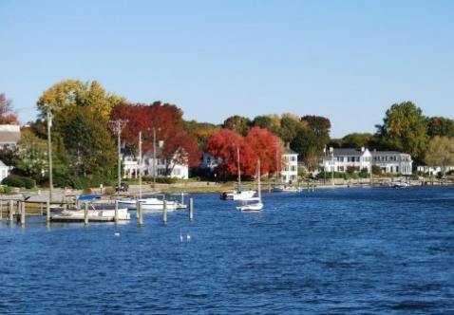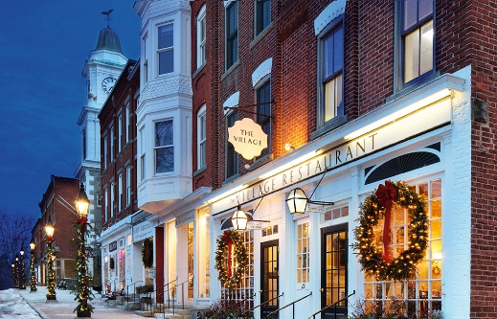

The Connecticut Office of the State Medical Examiner (OCME) is seeking two Full Time Special Investigators (ME) to work in our facility in Farmington, CT. The hours of work 40 hours per week, every third weekend and rotating holidays.

The OCME is a National Association of Medical Examiners (NAME) Accredited, centralized, state-wide medical examiner system with an autopsy load of approximately 3,000 per year (approximately 2,200 scene investigations) which includes approximately 150 homicides. We host interns from the University of New Haven Forensic Science Graduate program and have academic relationships with the medical schools at Yale, UCONN, and Quinnipiac University and all of the state pathology residency programs.
The OCME is a, free-standing, modern facility that is located in historic Farmington, CT on the Campus of the University of Connecticut Health Center and Medical School. The office is a state-wide medical examiner system charged with the investigation of sudden and unexpected deaths that by statute fall under our jurisdiction. Our agency operates 24/7/365 performing death investigations. Incumbents in this class are considered Level 1 essential employees and are hazardous duty designated. In addition to the checking of references and facts stated in the application, a thorough background investigation may be made before the candidate is certified for appointment.

Incumbents in this class will be required to:
- Travel statewide in response to scenes of death. Investigators are provided with a state-owned
vehicle which will be garaged at the incumbent's place of residence.
- Possess and retain a valid Motor Vehicle Operator's license.
- Work weekends and holidays on a rotating basis.
- Exposed to disagreeable conditions, including odors and situations
- Move and occasionally lift deceased human remains.

PURPOSE OF JOB CLASS (NATURE OF WORK)
This class is accountable for independently performing a full range of tasks in conducting investigations related to sudden and unexplained deaths.

EXAMPLES OF DUTIES

- Visit scene of death
- Review medical records
- Photograph scene
- Conducts investigations for sudden or unexplained deaths
- Interviews witnesses, medical and hospital personnel and others to obtain information
- Secures evidence in form of statements, documents, records and exhibits which may be used in
Court proceedings
- Writes reports and answers public inquiries
- May testify at hearings and in court
- May secure samples for testing
- May conduct legal research
- Performs related duties as required

KNOWLEDGE, SKILL AND ABILITY

Knowledge of medical terminology; knowledge of investigatory methods and techniques; knowledge of relevant state laws and regulations; knowledge of relevant professional terminology; interpersonal skills; oral and written communication skills; interviewing skills; ability to utilize computer software.

LOCATION:
Connecticut has charm, beauty, and a great quality of life. It is a place with mountains, forests, ocean front, rivers, and wonderful green countryside right at your doorstep. Connecticut is well above the US average in Education (ranked #14 in U.S.), Health (#4 in U.S.) and Public Safety (#6 in U.S.). If you want to enjoy your quality of life, it is the right time for a move to Connecticut.
Connecticut is family friendly and has some of the country’s best schools and educational systems. In Connecticut, you may enjoy the relaxed “country-life” or choose to live in a city. Hartford is home of the state government and New Haven is home to Yale University. Connecticut experiences all four seasons: summers are warm with plenty of sunshine for the beaches, rivers or hiking / biking trails; spring rapidly warms up with plenty of rain to feed the green countryside; autumn has spectacular gold, red, and brown foliage, and winter has plenty of snow for outdoor activities. It is a small state with access to Boston Massachusetts or New York City within a couple of hours by car or train. Vermont and New Hampshire are equally close, with easy access to hiking, skiing and snowboarding. Getting around Connecticut is very easy (even in the winter). Bradley International Airport, located 20 minutes from Hartford, has many direct domestic and a few international flights including destinations such as California, Florida, Puerto Rico, Texas, Chicago, Atlanta, Mexico, Montreal, Ireland and many more.
WHO SHOULD APPLY?
The Connecticut OCME is seeking enthusiastic people who desire to work and teach in a well-supported, statewide system with a diverse caseload. Applicants must have 5 years of investigatory experience in a medicolegal investigative agency, police or military setting involving sudden and/or unexplained deaths. Some substitutions are allowed (see below). We encourage current medicolegal death investigators with ABMDI certification to apply. Applicants with prior experience working in a medical examiner / coroner office and comfort with medical terminology are also encouraged apply.
QUALIFICATIONS:

MINIMUM QUALIFICATIONS - GENERAL EXPERIENCE
Five (5) years of investigatory experience in a medicolegal investigative agency, police or military setting involving sudden and/or unexplained deaths.

MINIMUM QUALIFICATIONS - SUBSTITUTIONS ALLOWED

1. College training in forensic science may be substituted for the General Experience on the basis of fifteen (15) semester hours equaling six (6) months of experience to a maximum of four (4) years for a Bachelor's degree.

2. A Master's degree in a closely related field may be substituted for one (1) additional year of the General Experience.

PREFERRED QUALIFICATIONS
Preference will be given to applicants with the following:

- ABMDI (American Board of Medicolegal Death Investigation) certification.
- Ability to adapt to high stress and traumatic situations.
- Experience working in a medical examiner/coroner office.
- Prior experience working in a medical setting.
- Experience reviewing medical records/medical terminology.
- Proficiency with Microsoft Office, web based systems.
- Experience writing investigative reports.

SPECIAL REQUIREMENTS
1. Incumbents in this class may be required to travel.
2 Incumbents in this class must possess and retain a valid Motor Vehicle Operator’s license.

Selection Plan:

All applicants must include a resume within the "Resume Tab" of their application with their submission. Applicants invited to interview may be required to submit additional documentation, which supports their qualification(s) for this position. These documents may include: performance reviews, supervisory references, college transcripts, licensure, etc., at the discretion of the hiring agency. All State employees shall follow the guidelines as listed in Executive Orders 13B (2a) and 13D (2a).
Compensation:
The starting baseline annual compensation as of September 2021 is $65,913 with growth within the pay scale up to $83,239. Holiday compensation is additional.
The Special Investigators are part of the A&R Bargaining Unit and are designated as Hazardous Duty.

Benefits / Conferences:
Comprehensive health and retirement benefits are provided by the State of Connecticut. Life and disability insurance, and other tax deferred programs are also available to State Employees. A State Vehicle is issued to Special Investigators for their use in responding to scenes of death. Educational conference leave (paid leave) is also offered to the incumbent, to attend lectures / meetings that pertain to the job duties and skill development / continuing education.

Conclusion:

The State of Connecticut is an equal opportunity/affirmative action employer and strongly encourages the applications of women, minorities, and persons with disabilities.

AddThis Sharing Buttons
Share to LinkedInShare to FacebookShare to TwitterShare to Email
TO APPLY:

The positing will close on 9/23/2021. Click on the link to apply: https://www.jobapscloud.com/CT/sup/bulpreview.asp?R1=210901&R2=7803AR&R3=001

If you should have any questions pertaining to any phase of this recruitment, please contact the Human Resources office at 860-952-9054.

