nature and scope

Pierce County, Washington, seeks a medical doctor or doctor of osteopathy for the position of Associate Medical Examiner. The person filling this position is responsible for working with the Chief Medical Examiner and staff
to plan, organize, direct and evaluate the activities of the Medical Examiner’s Office. Work primarily involves forensic pathology duties, including conducting autopsies to determine the cause
and manner of death for sudden, unexpected, violent, suspicious or unnatural deaths.

The office receives death notifications and performs investigations 24 hours a day, 7 days a week. Autopsies are normally performed Monday - Friday, excluding most holidays. However, occasional situations requiring a
pathologist to conduct an autopsy outside of normal business hours or visit a death scene may arise. This position is required to serve “on call” on a rotational basis outside regular office hours and on weekends, and when on call must be able to report for duty at the Medical Examiner’s office within 30-60 minutes.

This office has a close working relationship with organ and tissue procurement agencies; recoveries are typically performed in this facility.

The office also collaborates with neuropathology researchers at the University of Washington who are engaged in ground-breaking research focused on traumatic brain injury and neuronal mapping.
This office has an academic relationship with the pathology department of Madigan Army Medical Center and is a rotation site for pathology residents from Madigan Army Medical Center.

The office often provides training to other groups within Joint Base Lewis McChord and fire and police agencies within Pierce County.

This position reports to the Chief Medical Examiner.

about the medical examiner’s office

close knit
friendly staff
The medical examiner’s office has 23 full-time
employees providing investigations 24/7/365.

community partnerships
Serves as the teaching facility for the Pathology Department of Madigan Army Medical Center.

national accreditation
This office is fully accredited by the National Association of Medical Examiners, and has been continuously accredited since 1995.

state-of-art technology
Lodox xray (to be replaced by CT Scanner in 2022),
a new case management system, private toxicology for pending cases, and in- house transcription.

industry leader
Ground-breaking, award-winning partnerships with three local non- profit donation agencies.

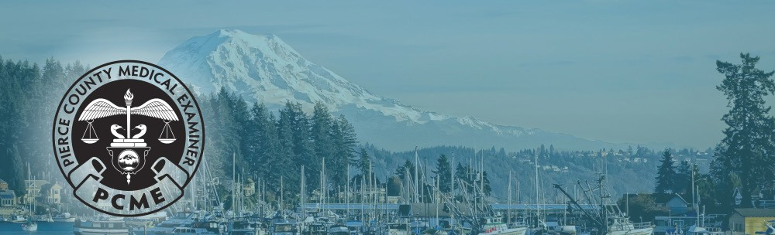

Pierce County Medical Examiner
ASSOCIATE MEDICAL EXAMINER
Employment Opportunity

Pierce County Medical Examiner | www.piercecountywa.gov/medex | 3619 Pacific Avenue, Tacoma, WA 98418 | (253) 798-6494

essential functions

- Participate in daily review of cases.
- Perform external and autopsy examinations, determine cause and manner of death, and provide appropriate documentation within designated timeframes and other professional and office accreditation standards.
- Confer with attorneys and provide accurate testimony in court.
- Provide technical support and training for forensic autopsy technicians and medicolegal death investigators and pathology residents.
- Participate in office accreditation and quality assurance, performance improvement, and workflow improvement efforts.
- Participate in mortality review.
- Participate in the training and education of pathology residents and medical students.

at a glance

- In 2020, Pierce County had an estimated population of 900,700 residents and registered 7,925 deaths. PCME received reports on 2,979 deaths and accepted jurisdiction over 1,293, resulting in 587 autopsy examinations, 273 external examinations, 407 records reviews, and 26 other exams.
- Toxicology is submitted to private lab on select cases when fast turnaround is needed (e.g., pending tox cases). Specimens are also sent to the Washington State Patrol Toxicology Laboratory. Toxicologists and analysts are available for consultation as needed.
- Forensic autopsy technicians provide full services, including evidence processing, photography, radiology, and evisceration. Medicolegal death investigators are the primary liaison to the public and other agencies. Investigators also provide full services, including ongoing case management and follow-up as needed. ABMDI certification is required for investigators.
- There is a full spectrum of additional laboratory services available, including special stains, chemistry, microbiology, viral cultures, and newborn genetic screening.
- Specialized consultations available, including forensic odontology, forensic anthropology, and neuropathology.
- Funding available for continuing medical education, including travel to one national meeting each year.
- The office pays for required licensing and memberships in professional organizations.
- Occupational health services are provided by HealthWorks.

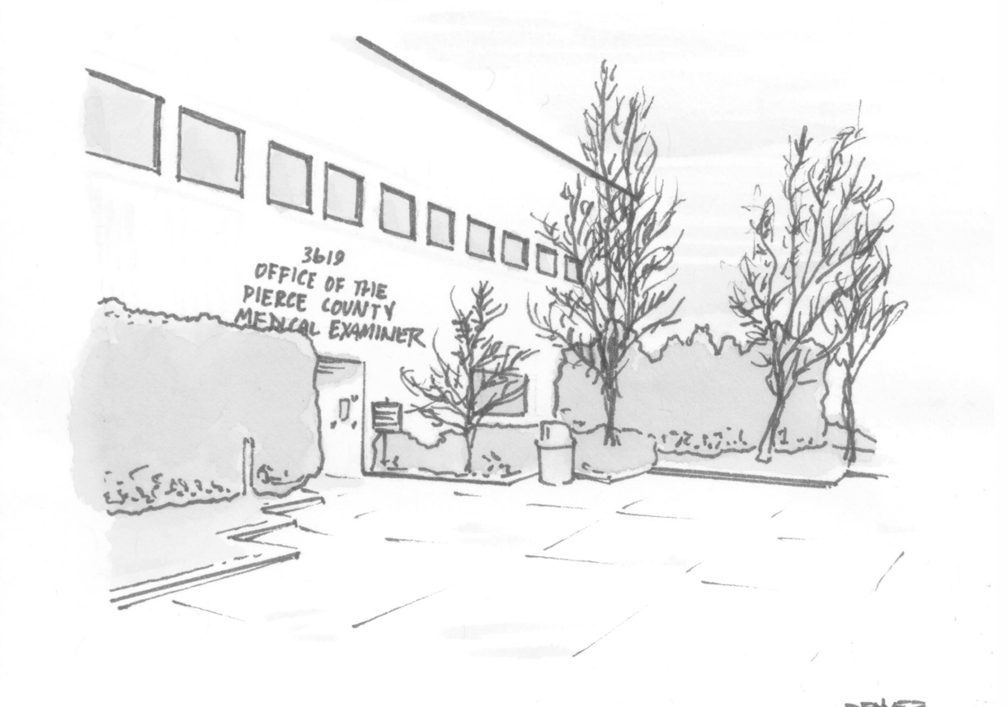

Pierce County Medical Examiner | www.piercecountywa.gov/medex | 3619 Pacific Avenue, Tacoma, WA 98418 | (253) 798-6494

live in Pierce County
compensation & benefits
The hiring salary range for this position is $201,622 to $267,997 depending on experience and qualifications. Benefits include a comprehensive package that includes medical, vision, dental and prescription coverage; vacation and sick leave; 12 paid holidays; life insurance; Washington State Public Employees Retirement; two Deferred Compensation Programs; a Health and Wellness Program; a variety of on-going training programs; Long-Term Disability Insurance; and commuting assistance.
From our world-class healthcare to our school districts and transportation, Pierce County is a great place to live. Our unique combination of urban and rural areas create the perfect place to call home.
minimum qualifications
Certified as a forensic pathologist by the American Board of Pathology (ABP) or a qualified physician eligible to take the American Board of Pathology exam in forensic pathology within one year of appointment. A physician specializing in pathology who is appointed to the position and who is not certified as a forensic pathologist must pass the pathology exam within two years of the appointment. If not currently licensed by the State of Washington, licensure must be obtained prior to the start of employment. If ABP certification is time-limited, must participate in American Board of Pathology Continuing Certification in Forensics Pathology.

application process
Persons interested in this position should submit the following information: a letter of interest specifically addressing the qualifications mentioned in this announcement and a current resume.
Apply online at www.piercecountywa.gov/jobs
If you are interested, you are strongly encouraged to contact Michael Franks, (253) 798-7810, michael.franks@piercecountywa.gov.
Pierce County is an equal opportunity employer and is strongly committed to enhancing the diversity of its workforce. We will provide assistance in the recruitment, application and selection process to applicants with disabilities who request such assistance.

Weather
Pierce County has a Mediterranean Oceanic Climate, featuring long, beautiful summers with average high temperatures in the mid 70s, and mild winters with average lows in the mid 40s. There is
little snow at sea level, but if you miss it, head to Mt. Rainier where you can build a snowman in July.

Transportation
Travel by land, air and water with the Port of Tacoma, Seattle-Tacoma International Airport and Pierce and Sound Transit's rail and bus system.

about Pierce County, Washington
Pierce County is governed by an Executive/Council form of government. The County boasts tremendous outdoor opportunities with miles of Puget Sound waterfront, Mt. Rainier National Park, 361 fresh-water lakes, alpine and cross-country skiing a short drive away, and nationally ranked year-
round golf courses in the vicinity, while also offering all the urban amenities. Major industries include health care, technology, agriculture, timber products and military installations.

Pierce County is home to the city of Tacoma, several suburban cities, small towns, and rural communities, as well as forests and farmlands. Pierce County’s moderate climate combined with a contrasting geography of water and mountains encourage a wealth of year round outdoor activities such as sailing, kayaking, fishing, skiing and hiking.

play in Pierce County
From the beautiful Tacoma Waterfront to Mt. Rainier and Chambers Bay, there are many places to explore and play in Pierce County.

Pierce County is home to world famous museums like the Lemay Car Museum and the Museum of Glass. There is also a vibrant arts scene where you can experience ballets, symphonies, live comedy, musicals, concert bands, popular music and other special events.

Pierce County Medical Examiner | www.piercecountywa.gov/medex | 3619 Pacific Avenue, Tacoma, WA 98418 | (253) 798-6494

