Associate Medical Examiner
Hillsborough County, Florida

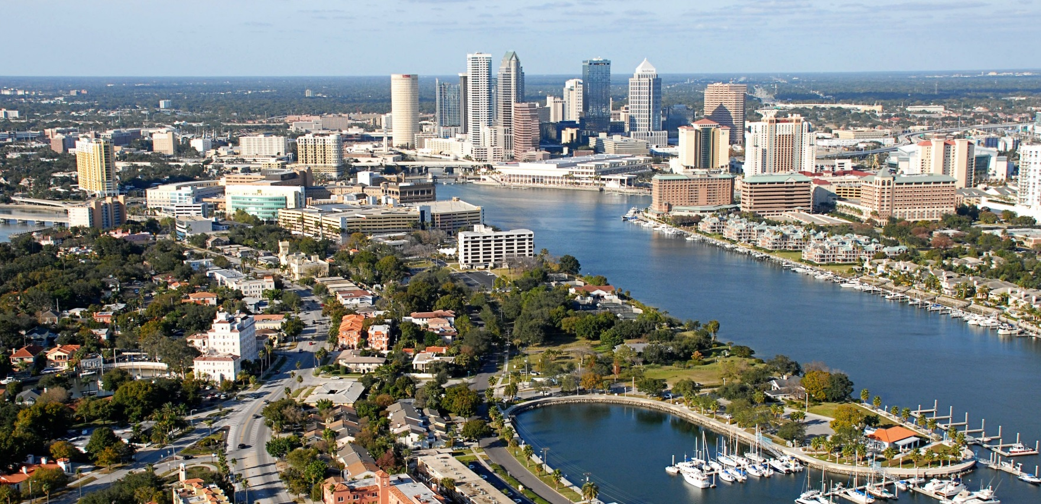
Hiring Range

Commensurate with Experience
Job Summary/Essential Job Functions
The associate medical examiner will perform functions of a forensic pathologist, conducting post-mortem examinations, and associated work duties.

Requirements
At minimum, applicants must have an MD or DO degree, certification by the American Board of Pathology in Anatomic Pathology and Forensic Pathology, and eligibility for medical licensure in Florida. If the applicant is not Board certified at the time of hiring, certification in both Anatomic and Forensic Pathology should be completed within two years.

Duties and Responsibilities
- Performs primary functions of a forensic pathologist in accordance with industry standards to determine manner and cause of death in medical examiner cases
- Maintains all required licenses and accreditations consistent
with the industry standards
- Maintains individual continuing medical education and assures compliance with licensing and certification requirements
- Assists in the training of forensic pathology fellow, participate in teaching the University of South Florida pathology residents, and medical students
- Provides expert testimony in criminal and civil court
as requested

Benefits
Hillsborough County participates in the Florida Retirement System, and provides an excellent benefit package including:
- Paid continuing medical education expenses
- At least 4 weeks annual leave
- Short- and long-term disability
- 401(k)
- Medical, dental, and vision insurance
- Professional membership dues and professional licensing fees

About Hillsborough County Medical Examiner
- In 2019, our pathologists performed 1,272 autopsies, 737
external examinations, and 7,848 case reviews.
- The Hillsborough County Medical Examiner facility was built in 2008 and includes 3 separate administration, morgue, and toxicology buildings.
- The facility is home to 2 board-certified forensic toxicologists, a board-certified neuropathologist, 12 ABMDI-certified medicolegal death investigators, a genealogist, 8 autopsy technicians, and 2 experienced transcriptionists.
- The 10-acre campus can support a mass fatality contingency while maintaining daily operations. A designated area provides room for refrigerated trailers that can accommodate an additional 200 bodies.
- The facility can sustain on-site operations following a hurricane. It was built on high ground with two days’ worth of back-up power.

To Apply
Contact Chief Medical Examiner Kelly Devers and send resume to District 13, Hillsborough County Medical Examiner
11025 N 46th St
Tampa, Florida 33617
813-914-4500
deversk@hillsboroughcounty.org

Human Resources

