COUNTY OF RIVERSIDE SHERIFF-CORONER
Salary up to $302,129.98
FORENSIC PATHOLOGIST III (AP/FP Board Eligible)
$204,766.02 - $274,677.10
FORENSIC PATHOLOGIST IV (AP/FP Boarded)
$225,230.10 - $302,129.98
Forensic Pathologist Position
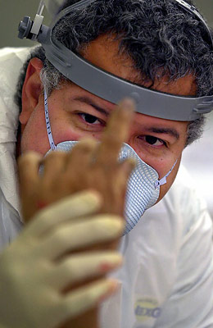
The Riverside County Sheriff's Department is seeking a dynamic and accomplished FORENSIC PATHOLOGIST III/IV to join its Coroner's Bureau. The selected candidate, under general direction, performs autopsies and other professional work in forensic pathology to determine the cause and time of death, testify in court, and contribute to the advancement of the Coroner’s Bureau.
This specialized classification is allocated to the Coroner's Office of the Sheriff's Department and reports to the Chief Forensic Pathologist. The Forensic Pathologist III classification is an underfill for the Forensic Pathologist IV classification. An incumbent at the III level has the necessary experience to provide the full range of forensic pathology duties; however, a III level incumbent is Board eligible for certification, whereas the IV level possesses Board Certification in Forensic Pathology. A Forensic Pathologist III incumbent is promoted to a Forensic Pathologist IV when proof of Board Certification as a Forensic Pathologist is provided to the Department. To be considered for employment, the applicant must possess the following qualifications: valid Physician's and Surgeon's Certificate issued by the State of California at the time of employment and, at a minimum, be eligible for certification in forensic pathology with the American board of Pathology.
Riverside County, California
Riverside County offers diversity that few counties can match. More than two million people live in Riverside County, taking advantage of affordable housing, nearby beaches, mountains, hiking and bike trails, the world-famous Wine Country near Temecula and resorts and casinos that offer oases in the desert. Riverside County is California's fourth largest county by population, with residents enjoying the Riverside County Fair and National Date Festival, the Balloon and Wine Festival, the Palm Springs International Film Festival, the Coachella and Stagecoach mega-concerts, the Paribas Open at the Indian Wells Tennis Center and the Humana Challenge, the golf tournament formerly known as the Bob Hope Classic. All those, combined with a rich cultural heritage and frontier history, make Riverside County a great place to live and work.
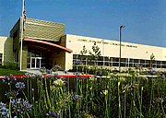
Riverside County Coroner has two facilities, with the main facility located in Perris. The Desert Forensic Center in Indio serves the eastern portion of Riverside County, covering approximately 30% of the forensic death investigations in Riverside County.
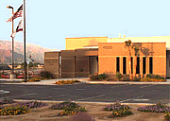
In 2020, the Coroner’s Bureau, which includes a Chief Forensic Pathologist, five full time forensic pathologist positions, and three part time forensic pathologist positions, performed approximately 1600 forensic autopsies. In addition, our Bureau also performs external examination "consultations," with ancillary support for toxicology, histology, and forensic anthropology, as well as contract forensic odontologists and a contract neuropathologist. State of the art equipment at Riverside Coroner includes a full body scan LODOX imaging system at both facilities and 128 slice CT Scanner to facilitate cause of death determination without a full forensic autopsy.
Please visit www.rc-hr.com to view the complete job bulletin and qualification requirements.
In addition to a competitive salary, Riverside County offers an attractive benefits package. Salary is commensurate with qualifications and experience:
Certificate Required: Possession of a valid physician’s and Surgeon’s Certificate issued by the State of California at the time of employment.
AND/EITHER
Forensic Pathologist III Level: Up to $274,677.10 annually
Eligible for certification in Forensic Pathology by the American Board of Pathology.
OR
Forensic Pathologist IV Level: Up to $302,129.98 annually
Certification in Forensic Pathology by the American Board of Pathology.
If you are interested in this position and to submit your resume/CV, please contact:
Carmen Posey
Human Resources Analyst, County of Riverside Human Resources Department
3450 14th Street Riverside, CA 92501
(951) 955-5736 Direct
(951) 955-5790 Fax
Email: cposey@rivco.org

For information regarding the Coroner’s operation, please contact:

Chief Forensic Pathologist Dr. Mark Fajardo 800 S. Redlands Ave
Perris, Ca 92570
951-443-2350 - Direct
Email: mfajardo@riversidesheriff.org
April Smith-Coroner’s Lieutenant
800 S. Redlands Ave
Perris, Ca 92570
(951) 443-2331- Direct
Email: atsmith@riversidesheriff.org

