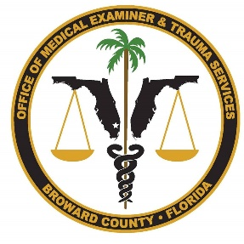
Office of Medical Examiner & Trauma Services
Broward County
Associate Medical Examiner
Salary range: $168,048.61 - $268,206.43 (ranges below)

The Office of the Broward County Medical Examiner and Trauma Services is seeking a highly qualified Associate Medical Examiner to join our team.
This National Association of Medical Examiners Accredited Office is in Broward County, Florida which serves a population of 1.9 million citizens and is currently the 17th-most populous in the United States.

Broward County is located at the center of the Southeast Florida “Gold Coast” between Palm Beach and Miami-Dade Counties. Broward County has a population of 1.9 million citizens within 1,200 square miles. The County includes 31 municipalities that lend to a broad spectrum of high-quality living environments as well as providing outstanding quality schools, libraries, and cultural activities with expansive parks and recreational amenities.

Candidates must be board certified in anatomic & forensic pathology or anatomic & clinical & forensic pathology by the American Board of Pathology or obtain such certification within 2 years of hire, and a current & active Florida Medical License

BENEFITS:
High risk FRS retirement
Consumer-Driven Health Plan (CDH)
Section 125 Flexible Spending Accounts
12 annual holidays
accrued annual/vacation and sick leave
Life insurance
Paid Licensure, CME, and conference attendance
Additional information about Broward County Benefits.

SALARY RANGES:
Associates with no boards are paid $187,200 annually.
Associates with Anatomic or Anatomic and Clinical boards are paid $218,399.92 annually
Associates with Forensic Boards are paid at the current rate of other Associate Medical Examiners at $251,746.51

Click here to apply:
https://www.governmentjobs.com/careers/broward?keywords=Associate%20medical%20examiner

