COUNTY OF SAN DIEGO
invites applications for the position of:

Forensic Pathology Fellow

19415705FY21-22

SALARY: | $89,232.00 - $89,232.00 Annually
OPENING DATE: | 06/18/19
CLOSING DATE: | Continuous
JOB SUMMARY:
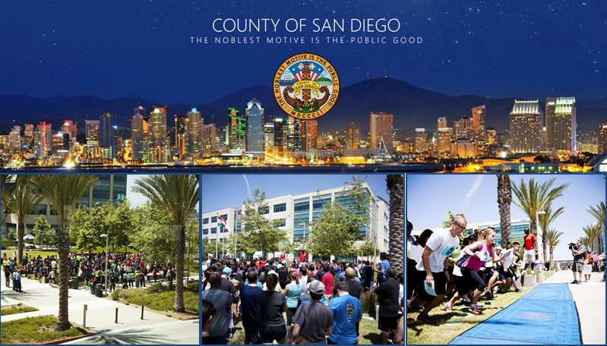

Forensic Pathology Fellow
YOU MUST APPLY ONLINE.
CLICK HERE TO APPLY
Are you a pathology resident looking for a career in medicolegal death investigations? Are you a practicing pathologist looking for a career change? Are you interested in finding the causes of sudden unexpected death, playing an active role in a criminal investigation, or determining just "what happened" when a person died?
The Department of the Medical Examiner currently has an open position for a Forensic Pathology Fellow.
This recruitment has a limited term for the academic year beginning July 1, 2021. Appointments to this job classification are limited to twelve months, or 2080 hours, and are not subject to Civil Service protection. Positions in this job classification are found exclusively in the Medical Examiner's Department.
Applications will be accepted from applicants who:
(1) Possess board certification in Anatomic Pathology or Anatomic and Clinical Pathology; OR, (2) Are eligible to take the Anatomic Pathology examination or Anatomic and Clinical Pathology Board examination by July 01, 2021.
At the time of appointment to the position July 1, 2021, applicants must possess a valid license to practice medicine in the State of California (California Business and Professions Code Section 2135).
Note: Anatomic Pathology training must have been approved by the Accreditation Council for Graduate Medical Education (ACGME).
****A copy of your Curriculum Vitae (CV) must be submitted with your application.
Three (3) letters of recommendation must be submitted directly from the sources to the following in order to be considered for this position:
County of San Diego - Medical Examiner
Attn: Dr. Stabley
5570 Overland Avenue, Ste 101
San Diego, Ca 92123-1215
Or by email: Robert.Stabley@sdcounty.ca.gov
Salary listed reflects that of current fiscal year, 2018-2019.
(Click here if you meet the qualifications above and are interested in viewing the complete class specification.)
IDEAL CANDIDATE
The County of San Diego desires a candidate that communicates effectively in English, both orally and written; is able to establish effective working relationships with management, employees, employee representatives and the public representing diverse cultures and backgrounds; and an individual who encompasses confidence in one's judgment and ability and willingness to be assertive in order to serve the best interest of the County.
NOTES:
- Please ensure all information is complete and accurate as the responses you provide on the supplemental application questionnaire will be reviewed using an automated evaluation system.

- This position may be eligible to participate in the Public Service Loan Forgiveness Program: https://studentaid.ed.gov/sa/repay-loans/forgiveness-cancellation/public-service

- Reasonable accommodations may be made to enable qualified individuals with disabilities to perform the essential functions of a job, on a case-by-case basis.

- Qualified applicants will be placed on a two-year eligible list with a score of 100.

- The County of San Diego now participates in E-Verify. CLICK HERE for additional information.
The County of San Diego and its employees embrace the Live Well San Diego vision: A region that is Building Better Health, Living Safely and Thriving. Click here for more information www.livewellsd.org.
Under California Government Code Sections 3100 - 3109, public employees are designated as disaster service workers. The term "public employees" includes all persons employed by the state or any county, city, state agency, or public district. Disaster service workers are required to participate in such disaster service activities as may be assigned to them by their employer or by law.

The County of San Diego is committed to valuing diversity and practicing inclusion because our diverse workforce is our greatest asset and our customers are our number one priority.
This is an opportunity to put your education and training to work - Apply Today!
Serving the Citizens of San Diego with Excellence
CLICK HERE TO APPLY

