FORENSIC PATHOLOGIST
SAN BERNARDINO COUNTY SHERIFF-CORONER DEPARTMENT

The San Bernardino County Sheriff-Coroner is seeking locum tenens who are board certified in forensic pathology. The forensic pathologist’s duties and responsibilities include: performing autopsies, providing the determination of the cause and manner of death, timely completion of autopsy reports, and providing expert testimony.

Locum tenens will be compensated by the case. As an added benefit, locum tenens are covered by the County’s Public Liability Insurance. Locum tenens will work when available, as needed by the Department.

Qualified candidates must possess a valid physician's and surgeon's license issued by the State of California, and board certification in Anatomic and Forensic Pathology from the American Board of Pathology.

San Bernardino County has a population of over two million and is located east of Los Angeles. It borders Nevada and Arizona and is the largest county in the contiguous United States. In 2018, the Coroner Division, which currently includes three full-time forensic pathologists and two part-time forensic pathologists, performed approximately 1500 forensic autopsies.

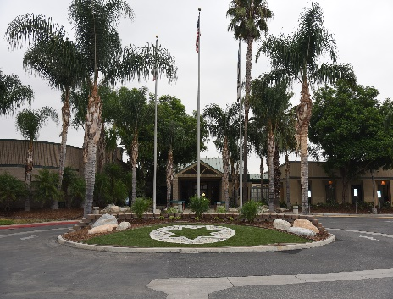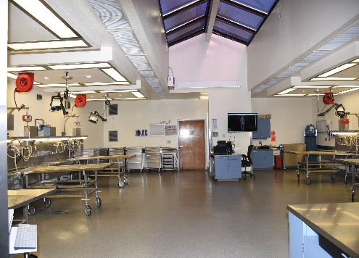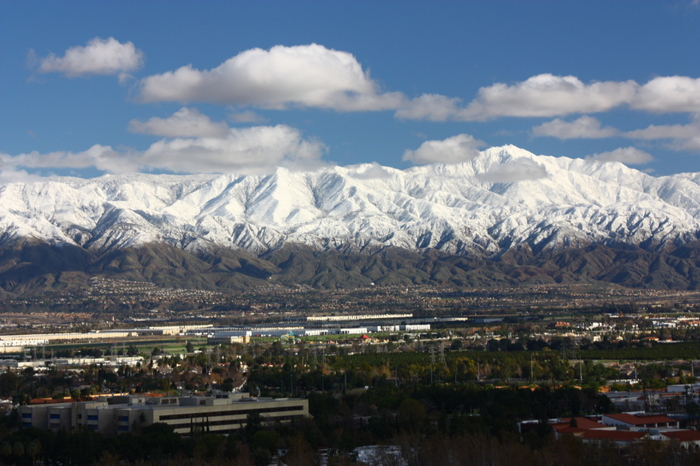

If you are interested in this position and would like to submit your resume/curriculum vitae, please
contact:

Dr. Chanikarn Changsri
Chief Forensic Pathologist
Email: cchangsri@sbcsd.org
Phone : (909) 387-2978
Address : 175 S. Lena Rd, San Bernardino, CA 92415

'

T

