



Shawnee Mission Park, Shawnee, KS Public Market, Lenexa, KS

**Immediate Opening: Deputy Medical Examiner**

Johnson County Government is seeking a qualified candidate to fill the position of a Deputy Medical Examiner. This position will serve as Deputy Coroner and Deputy Medical Examiner, second in command to the Chief Medical Examiner. This is a new position, in the newly created Medical Examiner’s Office. The Medical Examiner’s Office Building is currently under construction and is expected to open June 2020 in Olathe, KS. The building boasts state-of-the-art equipment, including a CT scanner and Lodox. In-house toxicology will also be offered in the 33,000 square foot location. The current office caseload is about 400 autopsies per year.

Johnson County, with a population of almost 600,000, is located in northeast Kansas and close to metropolitan Kansas City, Missouri – home to the 2020 Super Bowl champions, the Chiefs and the 2015 World Series winners, the Royals. In 2018, USA Today named Johnson County one of the top twenty best counties in the nation. Johnson County consistently ranks #1 in the “County Health Rankings” and is home to award winning parks (including several dog parks) and libraries. Johnson County has six excellent school districts and several colleges. Museums, shopping malls and the Kansas City International Airport are all nearby.

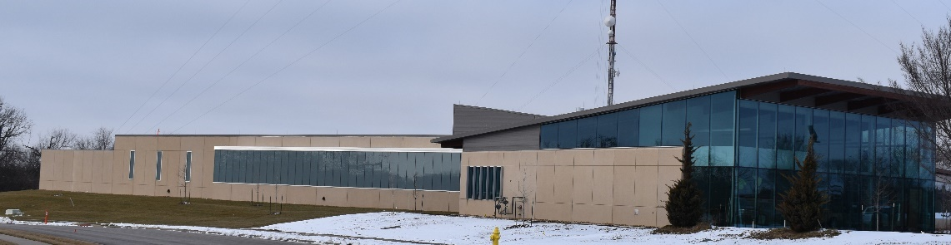

Johnson County Medical Examiner’s Building – January 2020

**Job Requirements**

* A Doctor of Medicine or Osteopathy, successful completion of an Anatomic Pathology or Anatomic and Clinical Pathology residency, and successful completion of Forensic Pathology fellowship from an accredited institution; Board certification in Anatomic Pathology or Anatomic and Clinical Pathology; Board certification in Forensic Pathology; Active non-exempt license to practice medicine in State of Kansas must be obtained prior to first day of employment.
* Knowledge of scene investigation and forensic pathology autopsy methods and techniques. Knowledge of the rules and collection of evidence, recovery, and evaluation, and identification of unknown decedents. Knowledge of the training and occupational requirements of the American Council of Graduate Medical Education (ACGME) as applicable to the field of pathology and National Association of Medical Examiner (NAME) accreditation standards.
* Skilled in dealing effectively and professionally with distraught or upset family members or situations. Skill in verbal and written communication to effectively present ideas, court testimony, or to assist in the investigation of possible criminal activity.

This position is full time (40 hours/week, full benefits). Pay range starts at $200,000.

*All offers of employment are contingent upon successful completion of a post-offer, pre-employment thorough background check. The candidate is required to possess a valid driver’s license with an acceptable driving record.*

*Johnson County is an equal opportunity/equal access employer and offers a competitive salary and benefits package (*[*https://www.jocogov.org/dept/human-resources/careers/benefits-wellness*](https://www.jocogov.org/dept/human-resources/careers/benefits-wellness)*). This is an unclassified position and is excluded from the County’s classification and compensation system.*

*Click on the link below or go to* [*careers@jocogov.org*](mailto:careers@jocogov.org) *to apply.*

<https://www.jocogov.org/dept/human-resources/careers/jobs-open-public>



Lexington Lake Park, DeSoto, KS

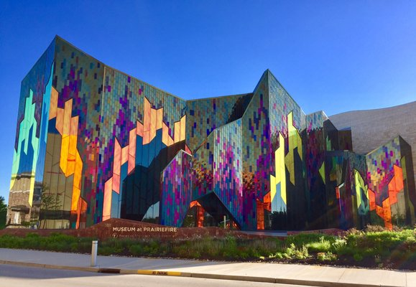 

Prairie Fire Museum, Overland Park, KS Cedar Lake Falls, Olathe, KS