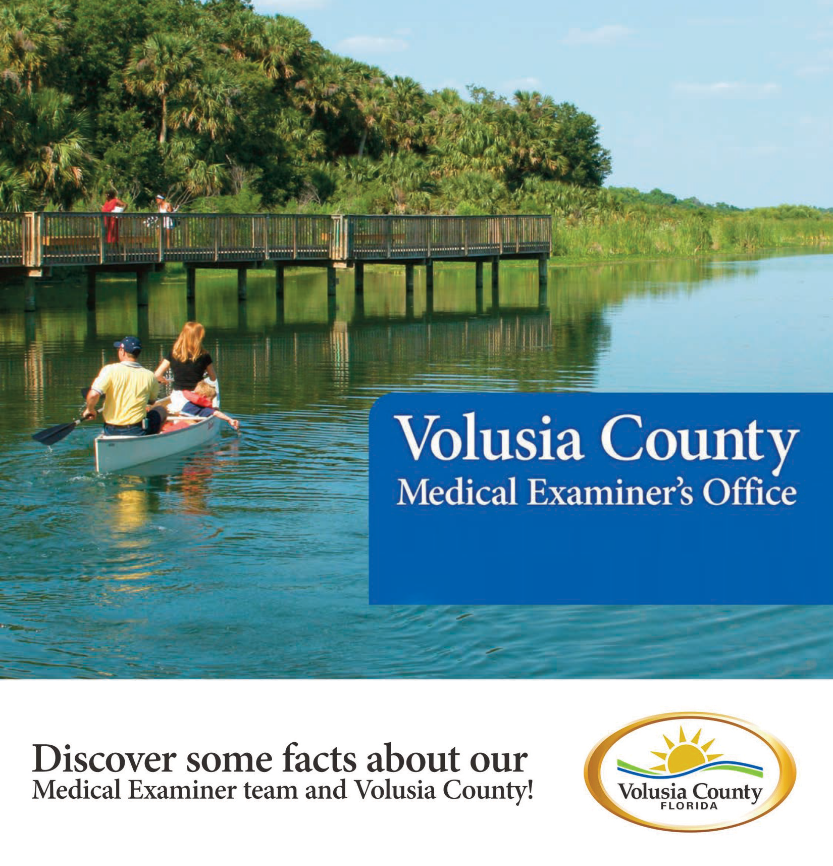
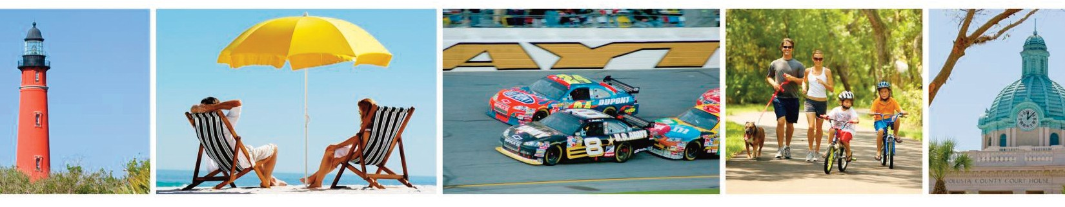

Chief Medical Examiner

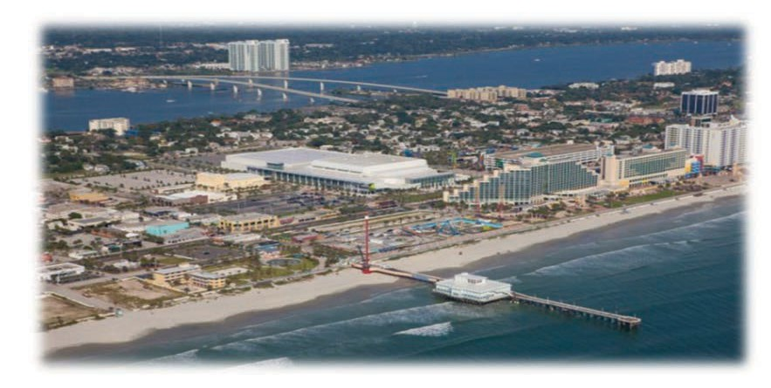

Volusia County is seeking a Chief Medical Examiner for the District Seven Medical Examiner’s Office. The Chief Medical Examiner develops and implements policies and procedures for a countywide forensic medical program as mandated by Florida State Statutes, Chapter 406, Florida Administrative Code 11G, and in accordance with the standards promulgated by the Florida Medical Examiners Commission.
Salary: $350,000
Supervise: 2 forensic pathologists
Office workload: 580 autopsies, 200 inspections

Volusia County has a population of 520,000 and has just over 7,000 deaths per year. Pursuant to Chapter 406, the Medical Examiner’s Office performs approximately 580 autopsies and 200 inspections. The Office performs 5,700 cremation authorizations per year.

The District Seven Medical Examiner’s Office has been recently reorganized into an independent agency with the Chief Medical Examiner functioning as an independent contractor. The reorganization has been performed under the guidance of the District Six Medical Examiner’s Office using a proven management model used in several Florida Districts. The Office has funding that can easily support the salary and benefits of the Chief Medical Examiner, two Associate Medical Examiners, and the support staff of administrative professionals, investigators, and technicians. The budget includes a 401k retirement plan, health, dental, disability, life, workers compensation, professional liability and unemployment insurance. Additional income is available from expert witness fees in civil and criminal cases.

The staff shall be the at-will employees of the Chief Medical Examiner. Expertise shall be provided for qualified applicants unfamiliar with the initial administrative tasks required prior to the inception date of the contract. A standard operating procedure manual and employee manual will be provided.
Medical Examiner duties are currently being provided by per diem forensic pathologists, so the applicant selected will have the opportunity to recruit the Associate Medical Examiners.
The current facility at 1360 Indian Lake Road, Daytona Beach, includes an administration center and a morgue operations building. Funding has been provided for the design of a new Medical Examiner facility. The applicant selected for this position will have the opportunity to provide input on the design and construction of the new facility, as well as, a new Medical Examiner database program.

MINIMUM REQUIREMENTS:
Graduation from an accredited school of medicine specializing in pathology and possession of a current license or eligible to obtain a license before the date of hire to practice medicine in the State of Florida as required by the Florida Department of Health, Board of Medicine or Osteopathic Medicine; and certified by the American Board of Pathology in Anatomical and Forensic Pathology. Florida licensure and board certification must be maintained as a condition of continued employment. Must possess and maintain a valid Florida driver's license or be able to obtain one by date of hire. The candidate will have at least five (5) years of experience as an Associate, Deputy, or Chief Medical Examiner.
Applicants send CV to:
Medical Examiner Search Committee
C/O Volusia County Human Resources Division
ATTN: Molly Hudson
230 N. Woodland Blvd. Suite 262
DeLand, FL 32720

For questions about the Medical Examiner’s office contact:
Jon R. Thogmartin, M.D.
Interim District Seven Medical Examiner
District Six Medical Examiner
jthogmartin@volusia.org
727-582-6800

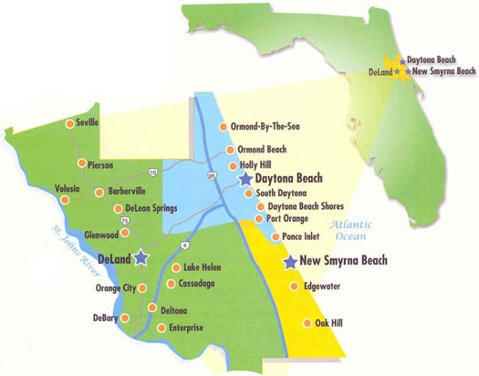

The Volusia County Medical Examiner’s Office serves all incorporated and unincorporated areas
within Volusia County
(Florida Medical Examiner District 7).

The coverage area of Volusia County includes the cities of Daytona Beach, Daytona Beach Shores, DeBary, DeLand, Deltona, Edgewater, Holly Hill, Lake Helen, New Smyrna Beach, Oak Hill, Orange City, Ormond Beach, Pierson, Ponce Inlet, Port Orange and South Daytona in Volusia County. The population expands with visitors to our famous beaches and during special events such as the Daytona 500, Bike Week, the July NASCAR races and Biketoberfest.

The District Seven Medical Examiner’s Office has funded support services for Toxicology (NMS), histology, forensic odontology, forensic anthropology, and neuropathology.

With featured cities like Daytona Beach, DeLand, Deltona, Ormond Beach and Port Orange, you can’t go wrong!

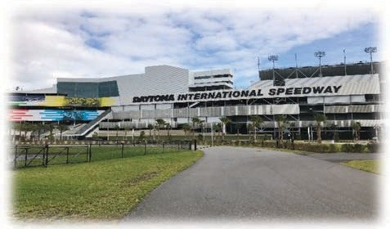

Volusia County is unique among Florida’s communities. With a wealth of natural re- sources, an established infrastructure and easy access to just about anywhere, it is the perfect place to live. We have a long list of firsts, bests and biggest – we are home to the World Center of Racing and the world’s largest Harley-David-
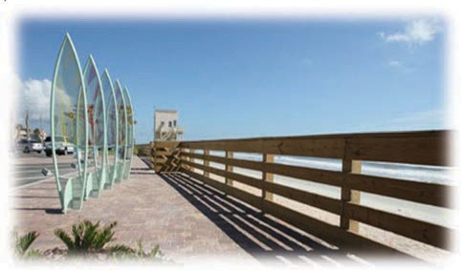
son dealership. We also host some of the most popular motorcycle and car events in the world. For chocolate lovers, we are proud to have a chocolate factory that’s been around for 85 years.
The area offers world-class beaches where the hard-packed sand allows motorized vehicles to drive on the beach in restricted areas. Residents and visitors also enjoy nature experiences, surfing, golfing, biking, multi-use trails, horseback riding, camping, historical and cultural facilities, bird watching and much more – all year long! World-class festivals and events take place throughout the year. Rich in diversity, culture and the arts, visitors have a wide range of museums, historical attractions and outdoor activities from which to choose. There's always plenty to see
and do. Visitors also have a range of accommo- dations including charming bed and breakfast inns, family-size condominiums and oceanfront hotels.

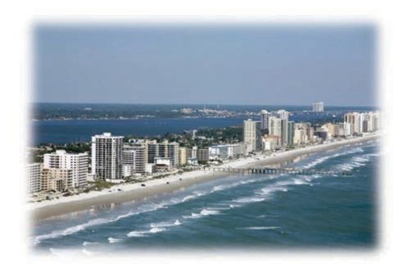
Aquatic Adventures

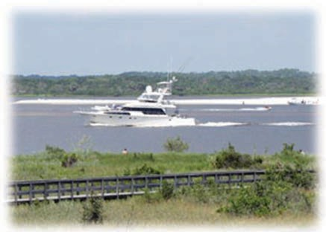

Whether you surf fish in New Smyrna Beach, the redfish capital of the world, or spend a lazy day angling on the pristine Indian River in Edgewater or on the Halifax River in Port Orange, aquatic adventures abound. Boat rentals, charters and expert guide services make fishing easy. Sit back and relax aboard a scenic riverboat excursion or get close to nature during a standup paddleboard or kayak trip along the many waterways.

You'll marvel at the variety of wildlife and beautiful estates along the Atlantic Ocean, Intracoastal Waterway, St. Johns River, Mosquito Lagoon and Spruce Creek. Local tournaments like FishStock, held every Memorial Day, attract anglers worldwide.

Deep-sea charters leave New Smyrna Beach and Ponce Inlet daily, giving offshore fishers an easy way to wet a line in the beautiful Atlantic Ocean.

Just south of New Smyrna Beach lies the Canaveral National Seashore, which offers excellent swimming, bird watching, hiking and more. Anglers at nearby Mosquito Lagoon have set international records with giant redfish catches.

With such titles as “The World’s Most Famous Beach” and “The World Center of Racing”, it is easy to see why Volusia County has long been a favorite destination. In addition to our rich history, we have a bright future. We are home to several renowned institutes of higher education, an established medical community and burgeoning manufacturing businesses. Volusia County
boasts resorts, attractions and the Daytona
International Speedway, home of the Daytona
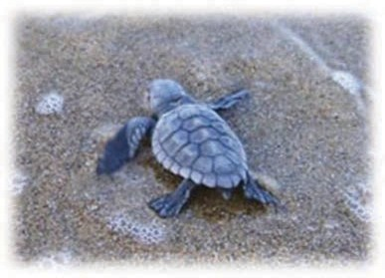
500. Volusia County has so much to do for everyone in every age group, making it the perfect place for the family.

Arts and Culture

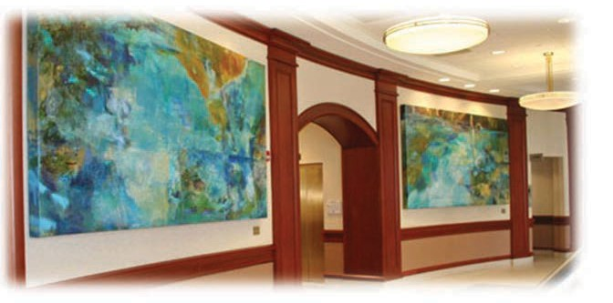

Many historical and cultural sites make Volusia County noteworthy. Art shows featuring visual and performing arts take place throughout the
year; they include the Fall Festival of the Arts, the Halifax Art Festival, and Images: A Festival of the Arts. New Smyrna Beach is home to the Atlantic Center for the Arts, an artists-in-residence community and educational facility. DeLand’s
Museum of Art displays various works of art year round. Daytona Beach’s own Museum of Arts & Science is the primary art, science, and history museum in Central Florida. Even if you do not go to museums, you will find art in public places as artists decorate murals and courtyards across the county.

Daytona Beach International Airport

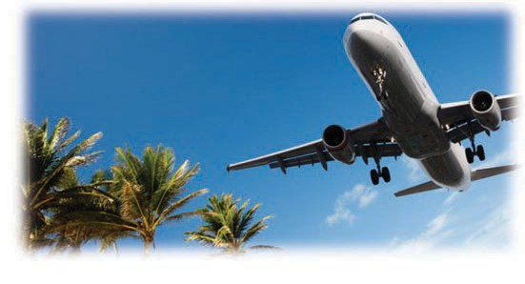
Daytona Beach International Airport makes travel fast, friendly and stress-free. And with flights available from American Airlines, Delta and JetBlue, the destinations are endless! We also have two other international airports nearby where you can travel to over 50 destinations all over the world.

Dining

Whether you’re looking for casual seafood on outdoor decks, a trendy new venue or something truly upscale, you'll find plenty of great restau- rants from which to choose – many along scenic waterways. When the sun goes down, enjoy a
delightful array of nightlife options. Stylish bars and nightclubs offer live entertainment including reggae, contemporary rock, blues and high- energy dance music.

Historical Sites

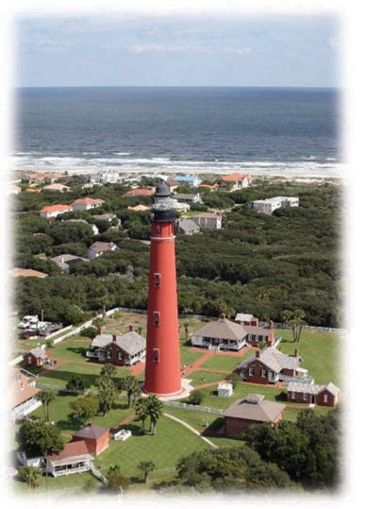
History buffs will marvel at the area's fascinating past with attractions that blend the area's rich history with educational activities. New Smyrna Beach represents the largest single attempt at colonial settlement in the United States. Dr. Andrew Turnbull, a Scottish physician and entrepreneur, established a colony along the west bank of the Indian River in 1768.

DeBary Hall, built in 1871, is the oldest intact building in southwest Volusia County. Presidents Ulysses S. Grant and Grover Cleveland spent their vacations in this unique and welcoming hunting lodge.

Volusia County has many historical sites, including the Turnbull and Sugar Mill Ruins, the Eldora State House and the Ponce de Leon Inlet Lighthouse and Museum.

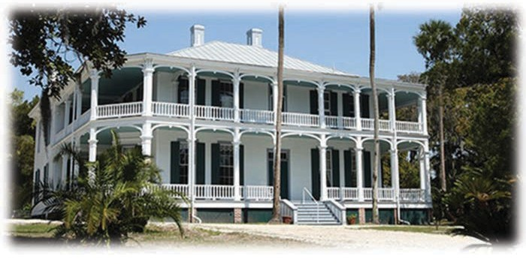

Outdoor Adventures

There is always a good excuse to relax with our state-of-the-art golf courses.

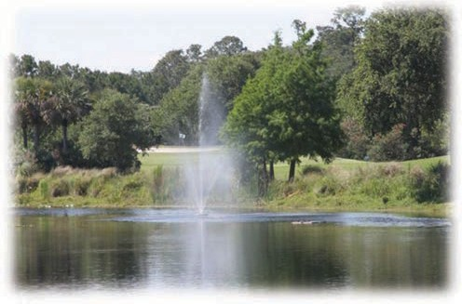

Love the great outdoors? Enjoy surf lessons and an array of deep sea and inshore fishing trips. Volusia County has activities for the young—and the young at heart. Our beaches offer some of the best surfing on the east coast of the United States.

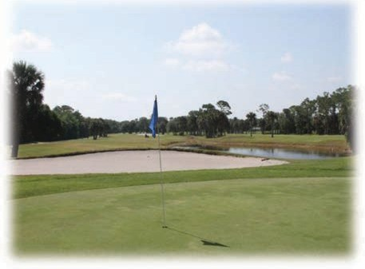
So get ready to “Hang Ten!” Volusia County has an extensive network of paved trails for biking, hiking, walking and running through some of the most scenic and pristine properties in Florida.

Surrounding Amenities and Attractions

You will never run out of fun and exciting things to do when you live in Volusia County!

Central Florida is a synonym for theme parks. Walt Disney World, Universal Studios and Sea World are an hour away from Volusia County.
You can have fun with the family and friends with attractions for all ages. If you are a big sports fan, we have professional sports teams including the Orlando Magic and Orlando City Soccer, which provide a great atmosphere and excitement during their home games.
Kennedy Space Center (KSC), Florida’s gateway to space, is just 40 minutes from Volusia County. At KSC you will be able to explore what it is like to be an astronaut and see space shuttles in person. You can also schedule your visit to see a rocket take off.

