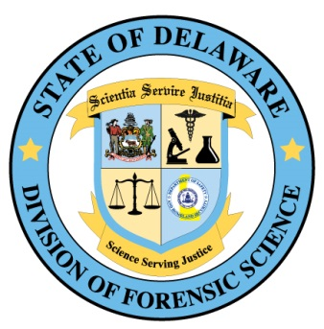

ASSISTANT MEDICAL EXAMINER/FORENSIC PATHOLOGIST
Recruitment #010220-MDEZ01-450100
Opening Date: 01/10/2020
Closing Date: 07/10/2020 or until position is filled
To view full posting information and to apply, go to www.delawarestatejobs.com

Job Summary: This position is for a Forensic Pathologist (less than 30 hours per week) who will conduct medical examinations of decedents in the state of Delaware. Responsibilities include medical examinations, coordination of staff during examinations and completion of all medical examiner records in the determination of cause and manner of death. This position has statewide responsibilities requiring travel within the State of Delaware with valid driver’s license in a state provided vehicle.

Job Requirements: Applicants must have education, training and/or experience demonstrating competence in each of the following areas:

1. Possession of an Anatomic Pathology Certification or eligibility for certification.
2. Possession of Delaware Physician M.D. or Delaware Physician D.O. license or eligibility for a
Delaware license.
3. Three years of experience in Forensic Pathology

Conditions of Hire:

1. Applicant must possess a Forensic Pathology certification OR agree as an employment requirement
to obtain board certification in Forensic Pathology within in 24 months of employment.
2. A satisfactory background check (including a fingerprint-based background check administered by the
Delaware State Police) is required as a Condition of Hire. The selected candidate will be required to
submit a buccal swab for DNA upon employment and is subject to randomized drug testing during the
term of employment.

Employment Details:

1. $125.00 per hour
2. Hours per week: not to exceed 29.75 (casual/seasonal employment status)
3. Shift hours: Monday – Friday, 8:00am – 4:30pm, weekends/holidays required
4. Primary work location: Division of Forensic Sciences, Sussex County, Georgetown, DE 19947
5. There are no benefits associated with this employment status.

To learn more about the Delaware Division of Forensic Science, go to https://forensics.delaware.gov

