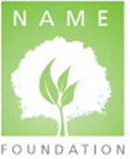
NAME FOUNDATION SILENT AUCTION FUNDRAISER

October 14 - 18, 2022
Fairmont Dallas, Dallas, Texas

Item name: Item value:

Donor organization:

Donor name:

Item description:

Insert Picture:

EACH BID MUST BE RAISED BY $ OVER PREVIOUS BID
 | Name | Phone Number | Bid Amount
1. |  |  | 30% of Value
2.
3.
4.
5.
6.
7.
8.
9.
10.
11.
12.
13.
14. BUY IT NOW |  |  | 3 X Value

